University of Louisiana at Lafayette

User Personas and Scenarios

Faculty and Staff – Dr. James Albert, Ph.D – Professor of Biology

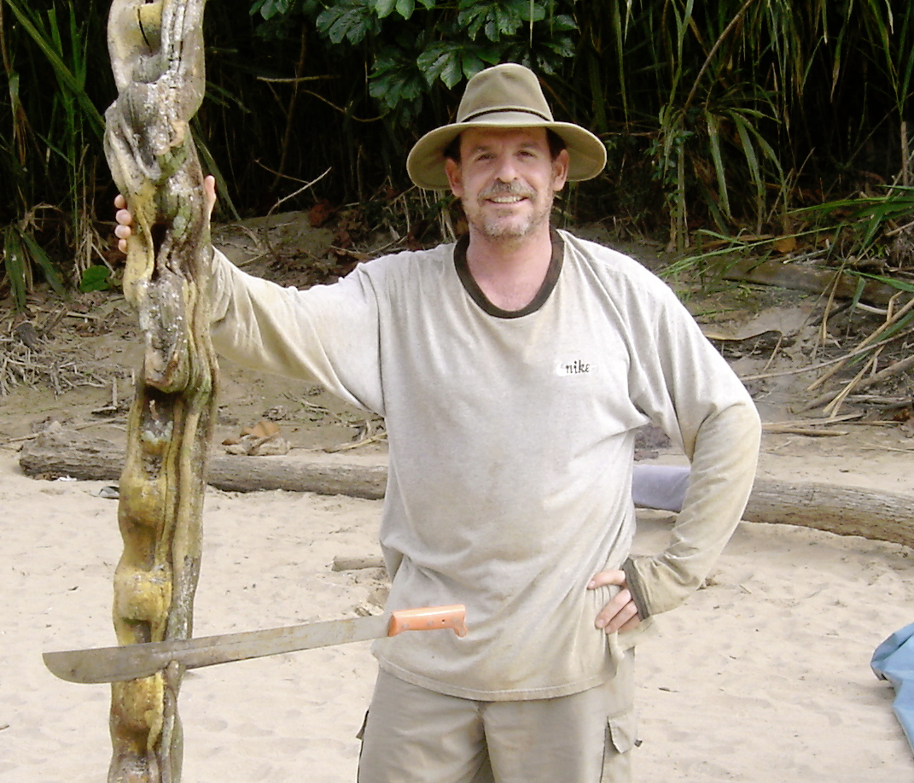
Professor James Albert is a Professor of Biology with the University of Louisiana at Lafayette. As a faculty member of the prestigious University of Louisiana at Lafayette, Dr. Albert is interested in the study of marine biology as his research is mostly devoted to diversity, systematics, and evolution of tropical fishes. Aside from his research interests, Dr. Albert is also perceptive to his financial well-being – including his personal state of wealth and funding for his research. Although Dr. Albert spends his majority of his time researching the state of tropical fishes, he also dedicates his time to writing research proposal grants. His biggest contributor is the National Science Foundation.

Although Dr. Albert’s research encompasses the majority of his time as a faculty member at the University, Dr. Albert also enjoys teaching as a biology professor. As of 2012, he currently mentors several graduate students in his laboratory and teaches undergraduate courses in marine biology. When he is not his lab, he is usually in his office generating exams and evaluating student performance. He also hosts office hours for his students so students may ask him questions about the content of his classes.

Link: http://biology.ucs.louisiana.edu/content/james-albert

